OO Programming Fundamentals

Practical Class 9 – Week 17th November 2014

- Create a Practical Week folder in your Java folder on your G drive

G:\Java\Practical Week 9

- Save all the following exercises into the Practical 9 folder

Exercise 1a
The following program uses a method called sum() to add two values. The values are passed from main() into sum(). sum() adds the 2 values together and returns the answer to main(). main() stores the returned value in a variable t and then prints the value of t to the screen:

import java.util.Scanner;

public class ex9a1
{
public static void main(String[] args)
{
Scanner input = new Scanner(System.in);
int a, b;
int t;
a = 7;
b= 9;
t = sum(a, b);
System.out.println("The sum of " + a + " and "+ b + " is " + t);
}

public static int sum(int x, int y)
{
int ans;
ans = x + y;
return(ans);

}
}
Enter the code in Bluej. Compile and run.
Save as ex9a1.java
Sample Output:
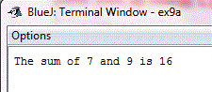
Exercise 1b
The program can be written without the variable t. The method sum() is called from within a System.out.print statement, and when a value is returned from sum() is it printed directly to the screen (instead of being stored in a variable like the previous program). Although both programs will produce the same output, it is often necessary to store the returned values from methods (as in exercise 1) as the returned values are often required for further calculations.
import java.util.Scanner;

public class ex9a2
{
public static void main(String[] args)
{
Scanner input = new Scanner(System.in);
int a, b;

a = 7;
b= 9;

System.out.println("The sum of " + a + " and "+ b + " is " + sum(a, b));
}
public static int sum(int x, int y)
{
return(x + y);

}
}

Enter the code in Bluej. Compile and run.
Save as ex9a2.java

Sample Output

Exercise 2
- Write a program using a method to convert Pounds into Kilograms
  - Ask the user to enter a Pounds value they would like converted to Kilograms.
  - Pass this value into a method called convertPoundstoKilos()
  - The method convertPoundstoKilos() should convert the Kilogram value using the following formula:
Kilograms= Pounds / 2.2;
  - convertPoundstoKilos() should then return the Kilogram value to main() where it should be stored in a variable and then printed to the screen.
NOTE***** Rounding to 2 decimal places:

double kilos, shortKilos;
kilos = 12.786876876;
shortKilos = Math.round(kilos * 100.0 ) / 100.0;
System.out.print(shortKilos);

Output:
12.78

Save as ex9b.java
Sample Output
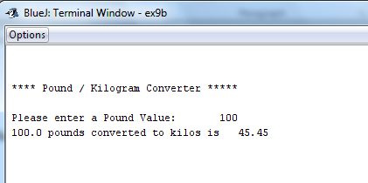

Exercise 3
Write a program using a method to convert from Kilograms into Pounds
- Ask the user to enter a Kilogram value they would like converted to Pounds.
- Pass this value into a method called convertKilostoPounds()
- The method convertKilostoPounds() should convert the Pounds value using the following formula:
Pounds= Kilograms* 2.2;
- convertKilostoPounds() should then return the Pounds value to main() where it should be stored in a variable and then printed to the screen.
Save as ex9c.java
Sample Output:
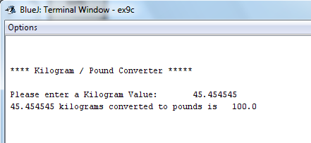

Exercise 4
Write a Kilogram/Pounds Converter Program (using a mixture Exercise 2 and 3)
Ask the user to decide whether they would like to convert Kilograms to Pounds or Pounds to Kilograms.
- If the user enters 1 - Convert from Kilograms to Pounds
- If the user enters 2 - Convert from Pounds to Kilograms
- Next, ask the user to enter the value they would like converted
- The program should then pass the value into a relevant method: convertPoundstoKilos() or convertKilostoPounds()
- The methods convertPoundstoKilos() and convertKilostoPounds() should calculate Pounds or Kilograms and return the relevant value to main() where it should be stored in a variable and printed to the screen.
- The user should then be given the option to enter another value and perform another conversion (use a do while loop).
Save as ex9d.java
Sample Output
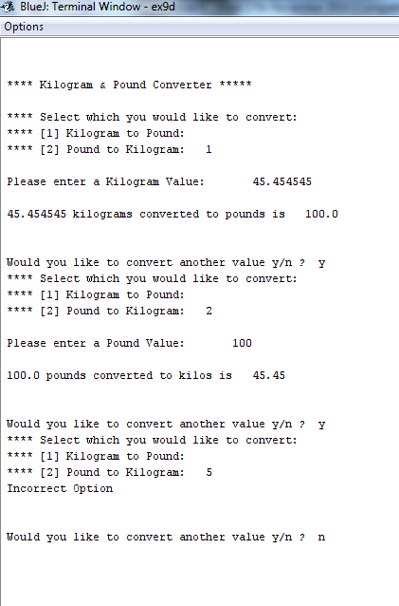

Exercise 5
* Write a program which asks the user to enter 2 integer numbers.
* Store the 2 numbers in 2 integer variables
* main() must pass these values into a method largestnum()
* largestnum()' should calculate which of the 2 numbers is largest (or equal) and return this value to main() where it should be printed to the screen.
Save as ex9e.java
Compile and run the program
Sample Output:
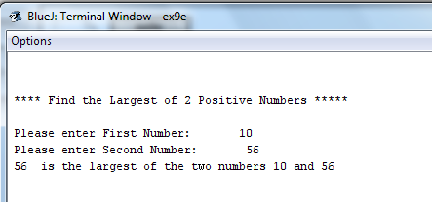
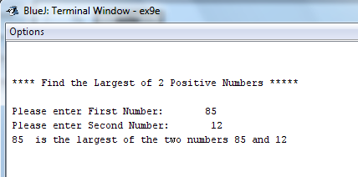
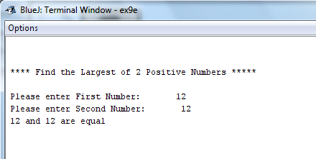

Exercise 6
Write a program which uses 2 methods to calculate the following formula: x = y2 – y - 2
main()
- Ask the user to enter a value
- Store values in variable y
- Call up method1 and pass in y
- Call up method2 and pass in y
- Take returned values and subtract them from each other - store answer in a variable and then print the answer to the screen.
method1()
- Take value from main()
- Multiply it by itself
- Return answer to main()
method2()
- Take value from main()
- Subtract 2 from the value
- Return answer to main()
Save as ex9f.java

Sample Output:
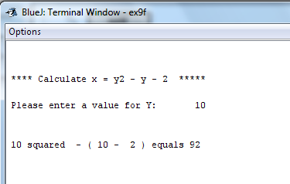

Exercise 7:
Write a program which uses 2 methods to calculate the following formula: y = 2 x + b / 6
The program must ask the user to enter the values for x and b
Use two methods: one to multiply 2 by x and a second one to divide b by 6.
Each method must return their answers to main where main should then finish calculating the equation and print the answer to the screen.
Save file as ex9g.java

Sample Output

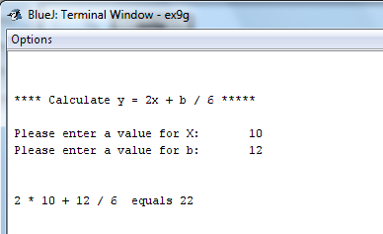

Exercise 8:
Write a program which has a number of methods for adding, subtracting, multiplying and dividing two integer numbers.
- Request 2 Integer numbers from the user.
- Display a menu to the user e.g.
    - Add
    - Subtract
    - Multiply
    - Divide

- If the user chooses 1 the pass the 2 entered numbers to a method which adds the 2 numbers and display the result to screen. Similarly for options 2, 3 and 4.
- Print an appropriate message for invalid menu options.
- Give the user the option to allow another calculation, or quit.
Save file as ex9h.java

Sample Output:

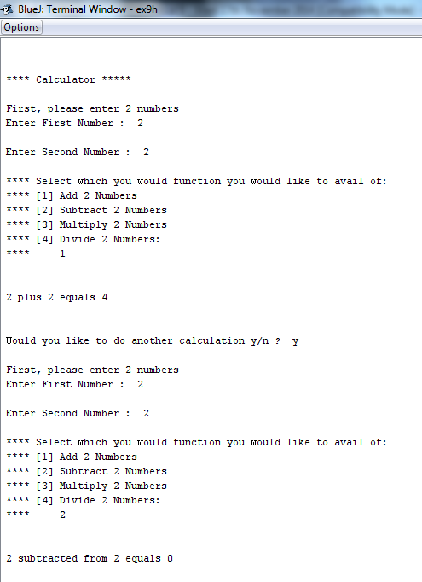
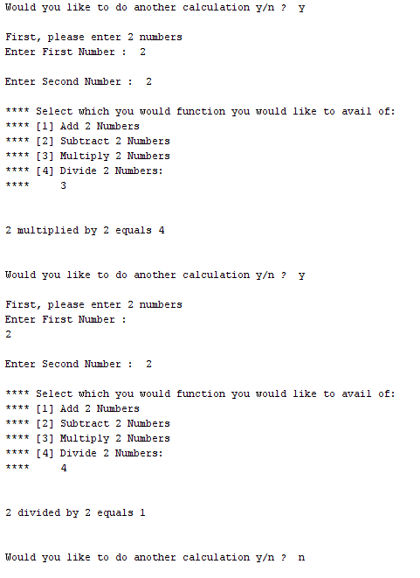

Completing this weeks’ Practical:
- When you submit work, you will send it in zip file format.
- To create a zip file of your practical work:
  - In Windows Explorer, right click on the Practical Week 9 folder that contains your work.
  - When the context menu appears, choose the Send to option, followed by the Compressed (zipped) folder.
  - This will create a new file called Practical Week 9.zip in your current folder
- Note: If you are using your own laptop, you can choose to install very good (and free) compression software called 7zip. Just search for it in Google and download it.

*** It is this zipped file that you will upload into Moodle.***

